Health and Wellness Wheel

Clutter and/or Disorganized
Nutritional Products

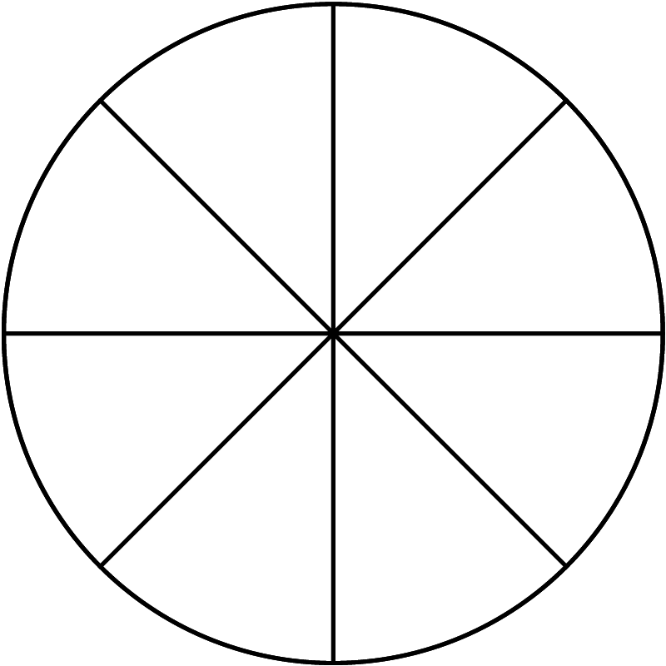
Exercise

Stress

Sleep
Weight

Diet
Fun &
Recreation
Instructions
Inside each section of the wheel, determine where you are on a scale from 0 to 10,
10 being the best, and draw a line across that section of the wheel.
For example, the innermost part of the wheel spoke where it is at its narrowest
would be a “0” and the outermost widest section of the wheel would be a “10”.
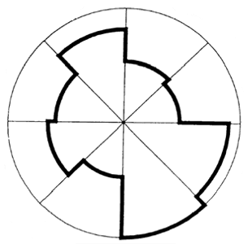
If this were a real wheel on your car – what kind of ride would you have?

